

Journal of Geophysical Research: Solid Earth

Supporting Information for

**Late Miocene hinterland crustal shortening in the Longmen Shan thrust belt, the eastern margin of the Tibetan Plateau**

Xiaoming Shen 1, Yuntao Tian 2,3, Guihong Zhang 2,3, Shimin Zhang 1, Andrew Carter 4, Barry Kohn 5, Pieter Vermeesch 6, Rui Liu 1, Wei Li 1

*1 Key Laboratory of Crustal Dynamics, Institute of Crustal Dynamics, China Earthquake Administration, Beijing 100085, China*

*2 Guangdong Provincial Key Laboratory of Geodynamics and Geohazards, School of Earth Sciences and Engineering, Sun Yat-sen University, Guangzhou 510275, China*

*3 Southern Marine Science and Engineering Guangdong Laboratory, Zhuhai 519082, China*

*4 Department of Earth and Planetary Sciences, Birkbeck, University of London, London WC1E 7HX, UK*

*5 School of Earth Sciences, The University of Melbourne, Melbourne, Victoria 3010, Australia*

*6 Department of Earth Sciences, University College London, London WC1E 6BT, UK*

**Contents of this file**

Figure S1. Relationship of eU versus ZHe and AHe ages.

Figure S2. Plot of ZHe age versus equivalent radius (Rs).

Figure S3. 2D scatter diagrams showing (a-c) results of the NA inversion and (d) comparison between observations and predictions by the best-fit model.

Table S1 A compilation of thermochronological data in central Longmen Shan for plotting Figure 4.

**Introduction**

This file includes two supporting figures and one supporting table which are (1) relationship of eU versus ZHe and AHe ages, (2) plot of ZHe and AHe ages versus equivalent radius (Rs), (3) plots of inverse modeling results of the second model, and (4) a compilation of thermochronological data in central Longmen Shan for plotting Figure 7.

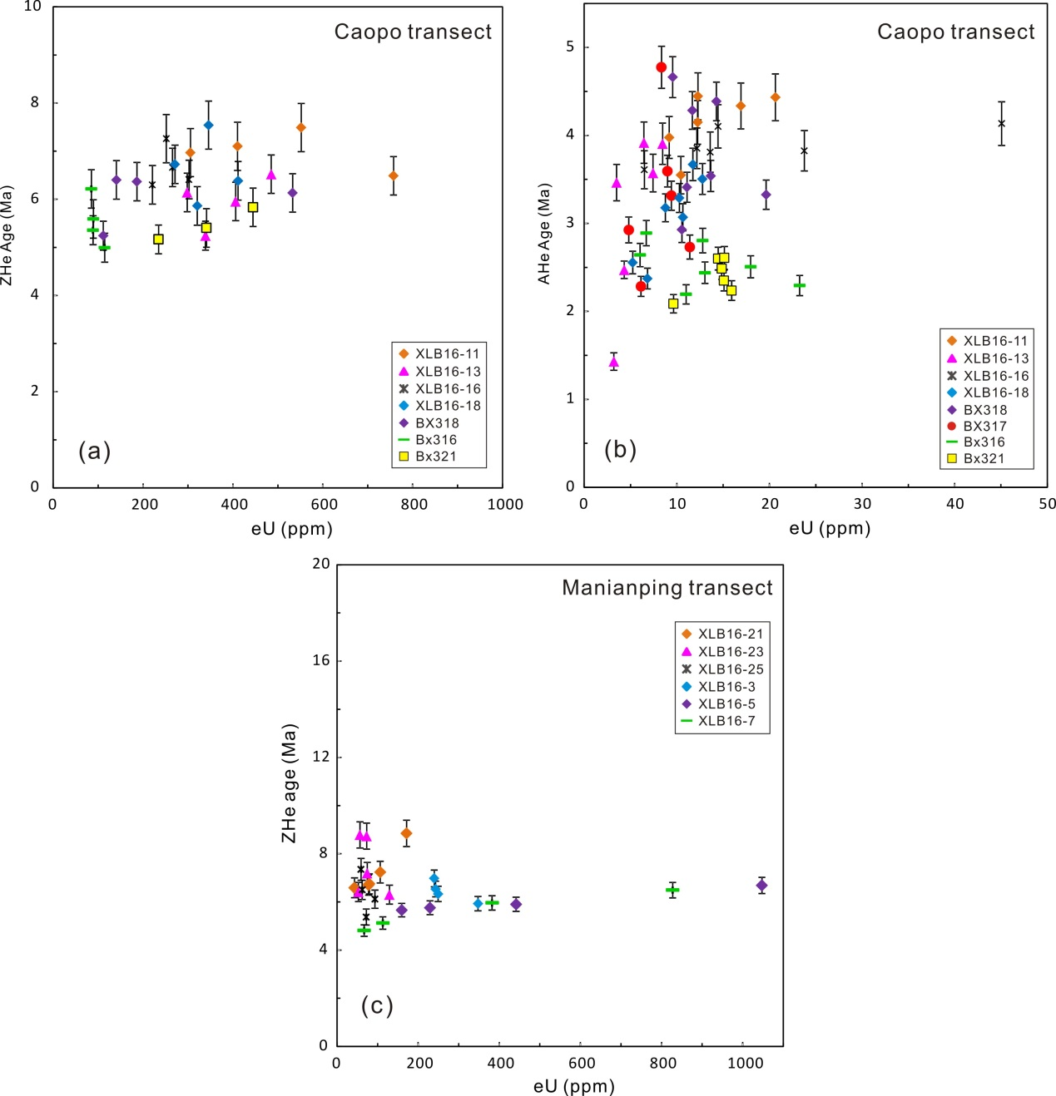

Figure S1. Relationship of eU versus ZHe and AHe ages of the Caopo and Manianping transects. These samples do not exhibit correlation, suggesting minor effects on the grains from radiation damage and not suffering slowly cooling.

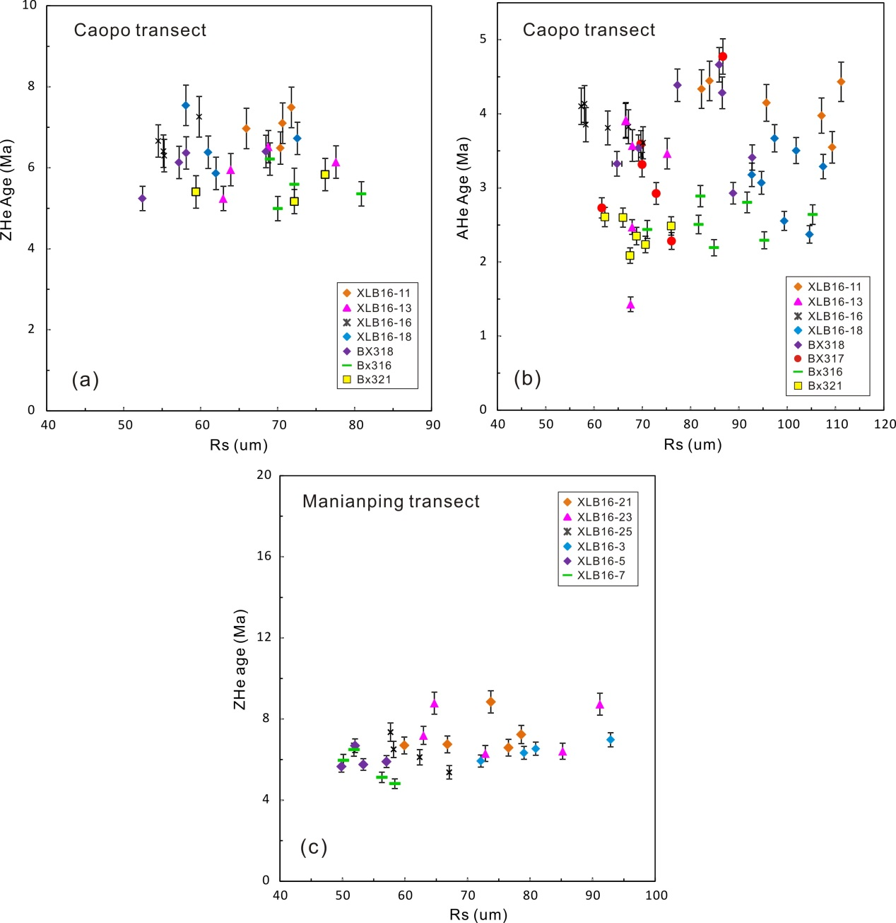

Figure S2. Plot of ZHe and AHe ages versus equivalent radius (Rs), which is the radius of a sphere with an equivalent surface area-to-volume ratio as a cylindrical crystal.

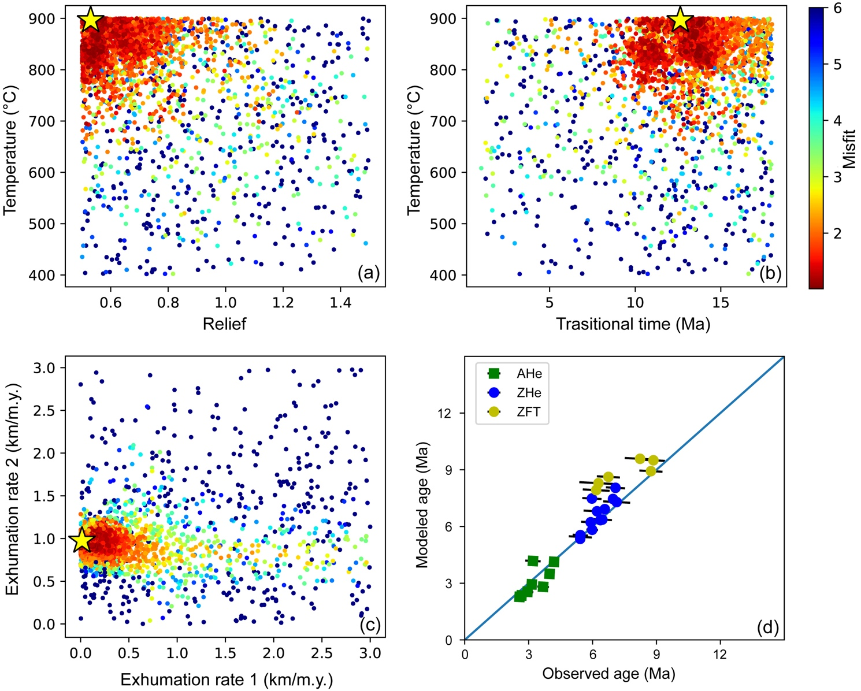

Figure S3. 2D scatter diagrams showing (a-c) results of the NA inversion and (d) comparison between observations and predictions by the best-fit model. Except for the basal temperature (400-900 oC), other setups are the same as the model shown in figure 5.

Table S1 A compilation of thermochronological data in central Longmen Shan for plotting Figure 7.

| Sample No. | Longitude | Latitude | Elevation | Age (Ma) | Error (1σ) | Age type | References |
| --- | --- | --- | --- | --- | --- | --- | --- |
| 0935-5 | 103.7997 | 31.0750 | 431 | 40.3 | 3.0 | AFT | Arne et al. (1997) |
| 1035-1 | 103.8000 | 31.1042 | 765 | 94.3 | 9.1 | AFT | Arne et al. (1997) |
| FT1 | 103.1308 | 31.7183 | 3950 | 6.6 | 1.0 | AFT | Arne et al. (1997) |
| FT2 | 103.1308 | 31.7183 | 3500 | 7.3 | 1.4 | AFT | Arne et al. (1997) |
| FT4 | 103.1308 | 31.7183 | 2750 | 3.9 | 0.6 | AFT | Arne et al. (1997) |
| FT-5 | 103.1109 | 31.6636 | 2400 | 3.8 | 1.3 | AFT | Arne et al. (1997) |
| FT-7 | 103.3993 | 31.0684 | 950 | 6.5 | 1.2 | AFT | Arne et al. (1997) |
| CW-6a | 103.3993 | 31.0684 | 1150 | 4.8 | 1.5 | AFT | Arne et al. (1997) |
| CW-3 | 103.7824 | 31.1177 | 800 | 173 | 8.5 | AFT | Arne et al. (1997) |
| FT93-152 | 103.4459 | 30.9351 | 800 | 39 | 5.0 | AFT | Arne et al. (1997) |
| HKT15 | 103.1700 | 31.0200 | 2081 | 4.9 | 0.5 | AFT | Arne et al. (1997) |
| FT93-154 | 103.8396 | 30.9896 | 900 | 168 | 10.0 | AFT | Arne et al. (1997) |
| FT1 | 103.1308 | 31.7183 | 3950 | 68 | 4.0 | ZFT | Arne et al. (1997) |
| FT4 | 103.1308 | 31.7183 | 2750 | 49 | 7.0 | ZFT | Arne et al. (1997) |
| FT-5 | 103.1109 | 31.6636 | 2400 | 38 | 2.0 | ZFT | Arne et al. (1997) |
| FT-7 | 103.3993 | 31.0684 | 950 | 110 | 7.0 | ZFT | Arne et al. (1997) |
| Mar-93 | 103.3902 | 31.0738 | 900 | 4.6 | 0.2 | AHe | Kirby et al. (2002) |
| Apr-93 | 103.3941 | 31.1549 | 900 | 11 | 0.5 | ZHe | Kirby et al. (2002) |
| LM223 | 103.6049 | 31.3886 | 2474 | 14.6 | 0.6 | ZHe | Godard et al. (2009) |
| LM225 | 103.5886 | 31.3797 | 3185 | 15 | 0.9 | ZHe | Godard et al. (2009) |
| LM226 | 103.5911 | 31.3779 | 3060 | 22.3 | 1.3 | ZHe | Godard et al. (2009) |
| LM227 | 103.5953 | 31.3812 | 2806 | 26.3 | 1.5 | ZHe | Godard et al. (2009) |
| LM228 | 103.5968 | 31.4154 | 2232 | 9 | 0.6 | ZHe | Godard et al. (2009) |
| LM229 | 103.5758 | 31.4249 | 1731 | 21.6 | 1.3 | ZHe | Godard et al. (2009) |
| LM2196 | 103.5981 | 31.4018 | 2190 | 7.8 | 0.3 | ZHe | Godard et al. (2009) |
| LM256 | 103.4917 | 31.4436 | 2330 | 12.2 | 0.7 | ZHe | Godard et al. (2009) |
| W1425 | 103.5264 | 31.4149 | 1439 | 9 | 0.6 | ZHe | Godard et al. (2009) |
| W1848 | 103.4989 | 31.4389 | 1860 | 7.2 | 0.4 | ZHe | Godard et al. (2009) |
| W2093 | 103.5040 | 31.4373 | 1956 | 8.55 | 0.5 | ZHe | Godard et al. (2009) |
| W2130 | 103.5022 | 31.4387 | 2130 | 11.1 | 0.5 | ZHe | Godard et al. (2009) |
| SC062 | 103.8981 | 31.3510 | 1726 | 9.1 | 0.4 | ZHe | Godard et al. (2009) |
| SC064 | 103.8575 | 31.3580 | 2061 | 19.8 | 0.8 | ZHe | Godard et al. (2009) |
| SC065 | 103.8542 | 31.3568 | 1927 | 13 | 0.5 | ZHe | Godard et al. (2009) |
| SC067 | 103.8878 | 31.3529 | 1807 | 12.4 | 0.5 | ZHe | Godard et al. (2009) |
| SC074 | 103.5370 | 31.2010 | 1755 | 20.6 | 0.9 | ZHe | Godard et al. (2009) |
| SC077 | 103.5325 | 31.2014 | 1526 | 7.5 | 0.3 | ZHe | Godard et al. (2009) |
| SC079 | 103.5227 | 31.2045 | 1350 | 4.04 | 0.3 | ZHe | Godard et al. (2009) |
| SC081 | 103.4955 | 31.2067 | 1056 | 9.9 | 0.4 | ZHe | Godard et al. (2009) |
| LM195 | 103.7541 | 31.3268 | 1495 | 11.6 | 0.5 | ZHe | Godard et al. (2009) |
| LM231 | 103.5169 | 31.3907 | 1295 | 10.1 | 0.4 | ZHe | Godard et al. (2009) |
| LM234 | 103.4870 | 31.2415 | 1130 | 17 | 0.7 | ZHe | Godard et al. (2009) |
| LM235 | 103.4768 | 31.1089 | 930 | 18.6 | 0.8 | ZHe | Godard et al. (2009) |
| SC083 | 103.3310 | 31.0709 | 930 | 12.5 | 0.5 | ZHe | Godard et al. (2009) |
| SC084 | 103.3577 | 31.0558 | 1452 | 6.3 | 0.3 | ZHe | Godard et al. (2009) |
| SC085 | 103.4672 | 31.0697 | 1712 | 60.7 | 2.5 | ZHe | Godard et al. (2009) |
| LM198 | 103.8496 | 31.1308 | 939 | 193.9 | 7.8 | ZHe | Godard et al. (2009) |
| LM208 | 104.0323 | 31.3489 | 811 | 228.7 | 9.2 | ZHe | Godard et al. (2009) |
| LM213 | 103.5757 | 31.0264 | 794 | 466.1 | 18.7 | ZHe | Godard et al. (2009) |
| W1425 | 103.5264 | 31.4149 | 1439 | 2.7 | 0.1 | AHe | Godard et al. (2009) |
| W1848 | 103.4989 | 31.4389 | 1860 | 2.1 | 0.1 | AHe | Godard et al. (2009) |
| W1848 | 103.4989 | 31.4389 | 1860 | 2.5 | 0.1 | AHe | Godard et al. (2009) |
| W2093 | 103.5040 | 31.4373 | 1956 | 2.3 | 0.1 | AHe | Godard et al. (2009) |
| W2093 | 103.5040 | 31.4373 | 1956 | 2.3 | 0.1 | AHe | Godard et al. (2009) |
| SC062 | 103.8981 | 31.3510 | 1726 | 4.8 | 0.2 | AHe | Godard et al. (2009) |
| SC065 | 103.8542 | 31.3568 | 1927 | 4.6 | 0.2 | AHe | Godard et al. (2009) |
| LM01 | 103.7200 | 31.0800 | 799 | 153.5 | 6.5 | AFT | Wilson and Fowler (2011) |
| LM03 | 103.4900 | 31.1400 | 987 | 7.7 | 2.3 | AFT | Wilson and Fowler (2011) |
| LM04 | 103.4900 | 31.2000 | 995 | 8.9 | 1.3 | AFT | Wilson and Fowler (2011) |
| LM07 | 103.4500 | 31.0700 | 1014 | 4.9 | 0.3 | AFT | Wilson and Fowler (2011) |
| LMW-01 | 103.6361 | 31.3833 | 4174 | 22.6 | 0.4 | AHe | Wang et al. (2012) |
| LMW-02 | 103.6403 | 31.3880 | 4009 | 0.8 | 0.6 | AHe | Wang et al. (2012) |
| LMW-06 | 103.6525 | 31.4156 | 3212 | 20.9 | 1.1 | AHe | Wang et al. (2012) |
| LMW-07 | 103.6622 | 31.4310 | 1908 | 10.9 | 0.3 | AHe | Wang et al. (2012) |
| LMW-08 | 103.6526 | 31.4430 | 1670 | 8.5 | 0.6 | AHe | Wang et al. (2012) |
| LME-09 | 103.6479 | 31.2907 | 2900 | 7.1 | 1.1 | AHe | Wang et al. (2012) |
| LME-11 | 103.6526 | 31.2874 | 2500 | 2.9 | 0.2 | AHe | Wang et al. (2012) |
| LME-13 | 103.6536 | 31.2853 | 2100 | 4.9 | 0.7 | AHe | Wang et al. (2012) |
| LME-14 | 103.6568 | 31.2848 | 2000 | 10.1 | 0.6 | AHe | Wang et al. (2012) |
| LME-15 | 103.6595 | 31.2830 | 1800 | 7.7 | 1.9 | AHe | Wang et al. (2012) |
| LME-16 | 103.6518 | 31.2676 | 1550 | 2.1 | 0.2 | AHe | Wang et al. (2012) |
| LME-17 | 103.6465 | 31.2289 | 1430 | 2.5 | 0.1 | AHe | Wang et al. (2012) |
| LME-18 | 103.6443 | 31.2165 | 1390 | 2.9 | 0.4 | AHe | Wang et al. (2012) |
| LME-19 | 103.6592 | 31.1740 | 1280 | 4.7 | 0.4 | AHe | Wang et al. (2012) |
| LME-20 | 103.6692 | 31.1607 | 1160 | 4.1 | 0.3 | AHe | Wang et al. (2012) |
| LMW-01 | 103.6361 | 31.3833 | 4174 | 56.5 | 19.8 | AFT | Wang et al. (2012) |
| LMW-02 | 103.6403 | 31.3880 | 4009 | 27.6 | 8.1 | AFT | Wang et al. (2012) |
| LMW-06 | 103.6525 | 31.4156 | 3212 | 17.8 | 10.6 | AFT | Wang et al. (2012) |
| LMW-07 | 103.6622 | 31.4310 | 1908 | 27.2 | 8.7 | AFT | Wang et al. (2012) |
| LMW-08 | 103.6526 | 31.4430 | 1670 | 19.9 | 4.2 | AFT | Wang et al. (2012) |
| LME-09 | 103.6479 | 31.2907 | 2900 | 27 | 4.1 | AFT | Wang et al. (2012) |
| LME-11 | 103.6526 | 31.2874 | 2500 | 19.8 | 3.0 | AFT | Wang et al. (2012) |
| LME-13 | 103.6536 | 31.2853 | 2100 | 23.5 | 2.8 | AFT | Wang et al. (2012) |
| LME-14 | 103.6568 | 31.2848 | 2000 | 18.4 | 3.1 | AFT | Wang et al. (2012) |
| LME-15 | 103.6595 | 31.2830 | 1800 | 17.3 | 2.7 | AFT | Wang et al. (2012) |
| LME-16 | 103.6518 | 31.2676 | 1550 | 21.3 | 5.7 | AFT | Wang et al. (2012) |
| LME-17 | 103.6465 | 31.2289 | 1430 | 23 | 2.8 | AFT | Wang et al. (2012) |
| LME-19 | 103.6592 | 31.1740 | 1280 | 15.1 | 2.7 | AFT | Wang et al. (2012) |
| LME-20 | 103.6692 | 31.1607 | 1160 | 15 | 2.2 | AFT | Wang et al. (2012) |
| LMW-01 | 103.6361 | 31.3833 | 4174 | 51.5 | 1.7 | ZHe | Wang et al. (2012) |
| LMW-03 | 103.6446 | 31.3979 | 3802 | 51.7 | 1.0 | ZHe | Wang et al. (2012) |
| LMW-05 | 103.6528 | 31.4129 | 3385 | 44.7 | 3.1 | ZHe | Wang et al. (2012) |
| LMW-07 | 103.6622 | 31.4310 | 1908 | 25.5 | 2.7 | ZHe | Wang et al. (2012) |
| LME-09 | 103.6479 | 31.2907 | 2900 | 37.4 | 2.5 | ZHe | Wang et al. (2012) |
| LME-11 | 103.6526 | 31.2874 | 2500 | 33.5 | 0.9 | ZHe | Wang et al. (2012) |
| LME-13 | 103.6536 | 31.2853 | 2100 | 33.9 | 1.8 | ZHe | Wang et al. (2012) |
| LME-15 | 103.6595 | 31.2830 | 1800 | 31.7 | 2.4 | ZHe | Wang et al. (2012) |
| LME-16 | 103.6518 | 31.2676 | 1550 | 23.9 | 1.6 | ZHe | Wang et al. (2012) |
| LME-17 | 103.6465 | 31.2289 | 1430 | 22.5 | 1.6 | ZHe | Wang et al. (2012) |
| LME-18 | 103.6443 | 31.2165 | 1390 | 24.7 | 0.9 | ZHe | Wang et al. (2012) |
| LME-20 | 103.6692 | 31.1607 | 1160 | 108.7 | 7.1 | ZHe | Wang et al. (2012) |
| LMW-01 | 103.6361 | 31.3833 | 4174 | 242.4 | 19.7 | ZFT | Wang et al. (2012) |
| LMW-05 | 103.6528 | 31.4129 | 3385 | 297.1 | 15.6 | ZFT | Wang et al. (2012) |
| LMW-07 | 103.6622 | 31.4310 | 1908 | 174.6 | 10.8 | ZFT | Wang et al. (2012) |
| LME-11 | 103.6526 | 31.2874 | 2500 | 263.1 | 17.6 | ZFT | Wang et al. (2012) |
| LME-17 | 103.6465 | 31.2289 | 1430 | 194.8 | 13.2 | ZFT | Wang et al. (2012) |
| LME-18 | 103.6443 | 31.2165 | 1390 | 197 | 23.4 | ZFT | Wang et al. (2012) |
| LME-20 | 103.6692 | 31.1607 | 1160 | 369.6 | 21.4 | ZFT | Wang et al. (2012) |
| Lm01 | 103.3863 | 31.3488 | 2026 | 9.3 | 0.4 | ZFT | Tan et al. (2017) |
| Lm02 | 103.3852 | 31.3418 | 1911 | 11.4 | 0.4 | ZFT | Tan et al. (2017) |
| Lm03 | 103.3968 | 31.3288 | 1752 | 8.4 | 0.3 | ZFT | Tan et al. (2017) |
| Lm04 | 103.4130 | 31.3122 | 1569 | 10.1 | 0.4 | ZFT | Tan et al. (2017) |
| Lm05 | 103.2451 | 31.5248 | 1658 | 12.5 | 0.5 | ZFT | Tan et al. (2017) |
| Lm06 | 103.4971 | 31.3660 | 1188 | 11.8 | 0.5 | ZFT | Tan et al. (2017) |
| Lm07 | 103.3782 | 31.3635 | 2346 | 10.1 | 0.4 | ZFT | Tan et al. (2017) |
| Lm08 | 103.3742 | 31.3560 | 2260 | 11.7 | 0.4 | ZFT | Tan et al. (2017) |
| Lm09 | 103.3825 | 31.3521 | 2147 | 10.3 | 0.5 | ZFT | Tan et al. (2017) |
| Lm10 | 103.3362 | 31.3626 | 2545 | 10.1 | 0.4 | ZFT | Tan et al. (2017) |
| Lm11 | 103.3555 | 31.3610 | 2500 | 10.5 | 0.5 | ZFT | Tan et al. (2017) |
| Lm19 | 103.7301 | 31.6004 | 1882 | 13.4 | 0.5 | ZFT | Tan et al. (2017) |
| Lm20 | 103.1280 | 31.6840 | 2258 | 42.9 | 1.1 | ZFT | Tan et al. (2017) |
| WCH-8 | 103.7500 | 31.1170 | 822 | 58.7 | 1.7 | ZFT | Tan et al. (2017) |
| LK-4 | 104.1540 | 31.4700 | 659 | 89.2 | 5.0 | ZFT | Tan et al. (2017) |
| JH-5 | 104.0220 | 31.4100 | 1090 | 86.2 | 4.0 | ZFT | Tan et al. (2017) |
| WCH-6 | 103.4800 | 31.0520 | 884 | 171.2 | 5.1 | ZFT | Tan et al. (2017) |
| JH-1 | 104.0580 | 31.3100 | 672 | 240.6 | 28.0 | ZFT | Tan et al. (2017) |
| JH-2 | 104.0320 | 31.2870 | 725 | 144.8 | 9.8 | ZFT | Tan et al. (2017) |
| C93-244 | 103.6697 | 31.5484 | 1650 | 131 | 0.3 | 40Ar/39Ar | Arne et al. (1997) |
| C93-246B | 103.5755 | 31.4962 | 1500 | 119.4 | 0.6 | 40Ar/39Ar | Arne et al. (1997) |
| BM-29 | 103.5408 | 31.3319 | 3240 | 160 | 0.4 | 40Ar/39Ar | Yan et al. (2008) |

**References:**

Arne, D., B. Worley, C. Wilson, S. F. Chen, D. Foster, Z. L. Luo, S. G. Liu, and P. Dirks (1997), Differential exhumation in response to episodic thrusting along the eastern margin of the Tibetan Plateau, *Tectonophysics*, *280*(3-4), 239-256.

Godard, V., R. Pik, J. Lave, R. Cattin, B. Tibari, J. de Sigoyer, M. Pubellier, and J. Zhu (2009), Late Cenozoic evolution of the central Longmen Shan, eastern Tibet: Insight from (U-Th)/He thermochronometry, *Tectonics*, *28*(5), TC5009.

Kirby, E., P. W. Reiners, M. A. Krol, K. X. Whipple, K. V. Hodges, K. A. Farley, W. Q. Tang, and Z. L. Chen (2002), Late Cenozoic evolution of the eastern margin of the Tibetan Plateau: Inferences from 40Ar/39Ar and (U-Th)/He thermochronology, *Tectonics*, *21*(1), 1-20.

Tan, X. B., X. W. Xu, Y. H. Lee, R. Q. Lu, Y. D. Liu, C. Xu, K. Li, G. H. Yu, and W. J. Kang (2017), Late Cenozoic thrusting of major faults along the central segment of Longmen Shan, eastern Tibet: Evidence from low-temperature thermochronology, *Tectonophysics*, *712–713*, 145-155.

Wang, E., E. Kirby, K. Furlong, M. van Soest, G. Xu, X. Shi, P. Kamp, and K. Hodges (2012), Two-phase growth of high topography in eastern Tibet during the Cenozoic, *Nature Geoscience, 5*(9), 640-645.

Wilson, C. J. L., and A. P. Fowler (2011), Denudational response to surface uplift in east Tibet: Evidence from apatite fission-track thermochronology, *Geological Society of America Bulletin*, *123*(9-10), 1966-1987.

Yan, D., M. Zhou, G. Wei, J. Gao, S. Liu, P. Xu, and X. Shi (2008), The Pengguan tectonic dome of Longmen Mountains, Sichuan Province: Mesozoic denudation of a Neopro-terozoic magmatic arc-basin system, Science in China Series D-Earth Sciences, 51(11), 1545.